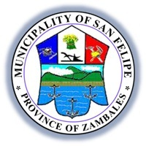
Republic of the Philippines
Province of Zambales
Municipality of San Felipe
***
MUNICIPAL TOURISM, INVESTMENT AND PROMOTION OFFICE
MUNICIPAL CULTURE AND ARTS OFFICE

INVENTORY LIST OF CULTURE AND THE ARTS

Name of Property | Location | Significance or how the property depicts/represents the identity of the locals | Type (Movable Tangible, Immovable Tangible or Intangible) | Ownership | Photograph of related multimedia files (video, audio, etc), if available
1. Municipal Hall  Of the Municipality of San Felipe, Zambales | Brgy. East Feria, San Felipe, Zambales | Houses the main executive and legislative offices of the Local Government Unit | Immovable Tangible | Government Property | 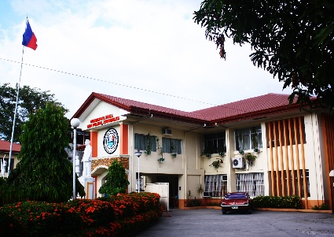
2. San Roque Parish Church | Brgy. East Feria, San Felipe, Zambales | Founded in 1859 by the Spanish Friars. The Recollect Fathers from the Archdiocese of Manila, stationed at nearby San Narciso, were the first ones to administer and care for the religious needs of the faithful of the town. | Immovable Tangible |  | 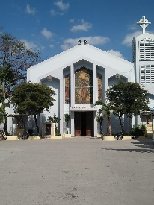
3. Benedictine Retreat House | Brgy. Sindol, San Felipe, Zambales | 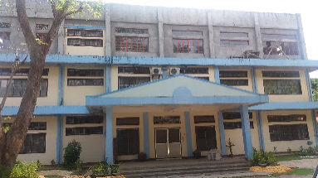  This compound was first used to house relocated groups that were displaced by the Mt. Pinatubo eruption in 1991. Today, it serves as a modest sanctuary for retreats and recollections that traces the tranquility and peace that the victims of the Mt. Pinatubo eruption after they sought refuge thereat after the devastation. Guests can now also buy religious articles specially made by the members of the religious congregation. | Immovable Tangible
4. Municipal Public Auditorium | Brgy. East Feria, San Felipe, Zambales | Used for various cultural activities such as Community Affairs, Balikbayan Nights, etc., this venue serves as a reminder of the rich culture and heritage of the town showcased in songs, dances and family celebrations | Immovable Tangible | Government Property | 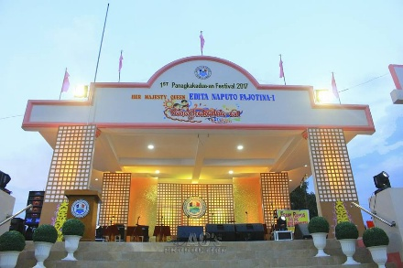
5. Liwasang Bayan | Brgy. East Feria, San Felipe, Zambales | Used for various cultural activities, this venue serves as a reminder of the rich culture and heritage of the town showcased in songs, dances, streetdancing and family and community celebrations | Immovable Tangible | Government Property | 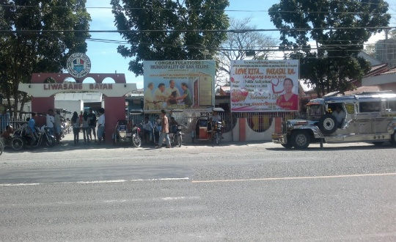
6. San Felipe Multi-Purpose Hall | Brgy. Sto. Niño, San Felipe, Zambales | Used for various cultural activities, a gift from the Governor of the Province of Gyeongsangbuk-do, South Korea, it served as a reminder of the friendship and mutual cooperation forged between the Province of Gyeongsangbuk-do and the Province of Zambales and  the Municipality of San Felipe. | Immovable Tangible | Government Property | 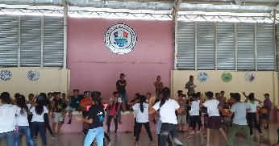  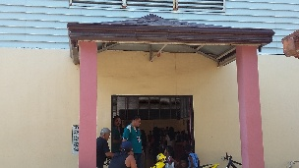
7. San Felipe Community Centrum | Brgy. East Feria, San Felipe, Zambales | Used for various cultural activities, seminars, LGU meetings/dialogues/consultations including family gatherings, it was a product of community effort. It was damaged by the Mt. Pinatubo eruption in 1991 and remained unutilized until 2012 when it was again rebuilt, a fitting reminder of how San Felipeneans rise in every fall and challenges. | Immovable Tangible | Government Property | 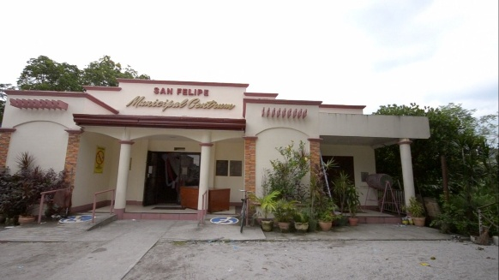  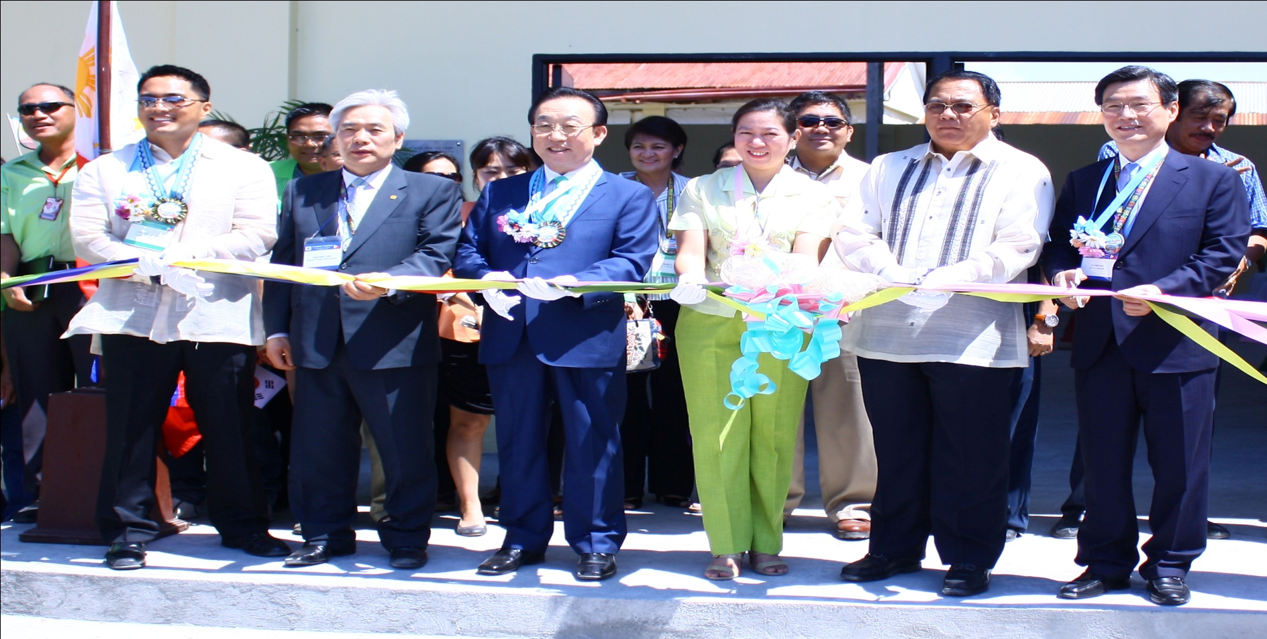
8. Barangay Hall and Plazas of the 11 Barangays of the Municipality | Brgy. Amagna  Brgy. Apostol  Brgy. Balincaguing  Brgy. Farañal  Brgy. Feria  Brgy. Maloma  Brgy. Manglicmot  Brgy. Rosete  Brgy.San Rafael  Brgy. Sindol  Brgy. Sto. Niño | Barangay Hall- Serves as the evacuation center during disasters. Barangay Hall is used for Barangay agendas and various barangay projects and activities. This also serves as the station of the barangay officials such as the Barangay Captain, Barangay Kagawads and SKs and where they can deliver their services to the barangay folks.  Barangay Plaza- Used for various barangay affairs and for various barangay cultural activities. | Immovable Tangible | Government Property | 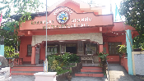  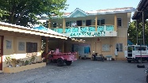  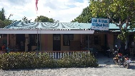  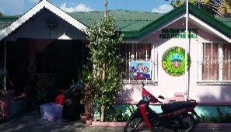  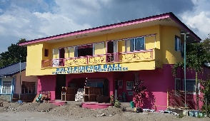  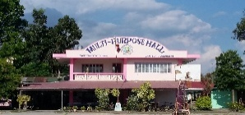  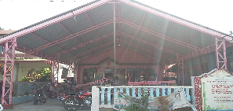  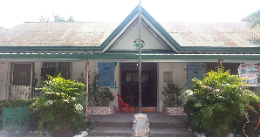  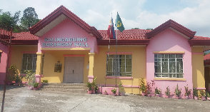  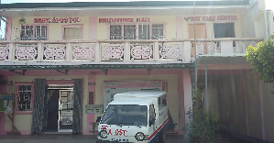  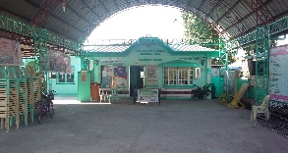
9. Century Old Acacia Tree | Brgy. Maloma | This Acacia Tree is a century old tree and one of the town’s most iconic tourist spots. It remains a reminder of how the town and its people takes care of its environment, thus, making San Felipe remains to be known as the cleanest and greenest in Zambales. | Immovable Tangible |  | 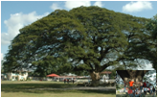
10. Public Market/Public Mall | Brgy. West Feria, San Felipe, Zambales | The Public Market serves as the window for local products, goods and harvest. It was the first Public Market in Zambales to have implemented the “No Plastic Policy”. It offers San Felipe’s One-Town, One Product namely chicharon and longganisa.  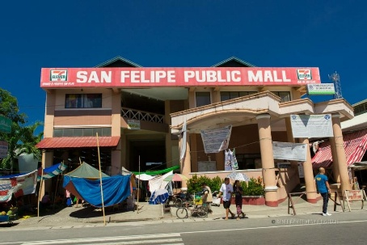  The Public Mall serves as a hub for businesses such as boutiques, beauty parlors, computer shops and even a technological college. | Immovable Tangible | Government Property | 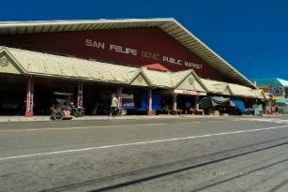
11. Site of the Tomb for the Unknown soldiers | Brgy. Apostol, San Felipe, Zambales | The tomb of the unknown soldiers is the site for the soldiers who fought the battle during the World War II. The tomb was built to commemorate the heroism of the people from San Felipe who fought for the country during the war. | Immovable Tangible | Government Property | 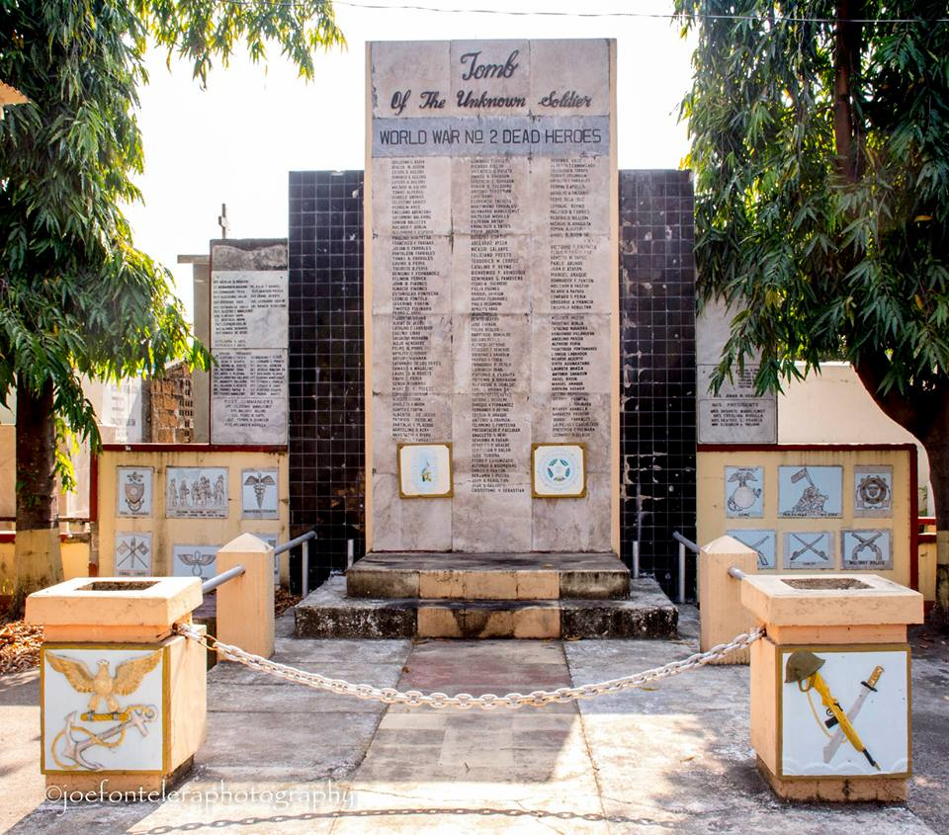
12. Saemaul Undong-Cooperation and Friendship Village | Brgy. Balincaguing, San Felipe, Zambales | The country’s first-ever pilot village for the spirit of self-help, diligence and cooperation. Barangay Balincaguing is a model of transformation to one of the most productive communities in agro-tourism development. An array of showcases from bio-gas, organic compost fertilizer production, greenhouses, sanitation and best environmental practices, this has become a model and served as a window of international cooperation between San Felipe and the Republic of Korea through the Saemaul Undong Program. | Immovable Tangible | Government and NGO owned Program | 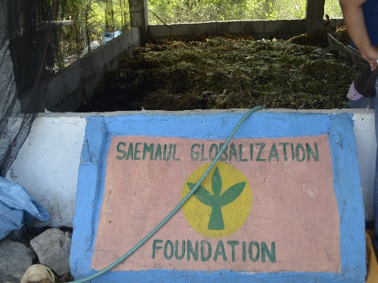  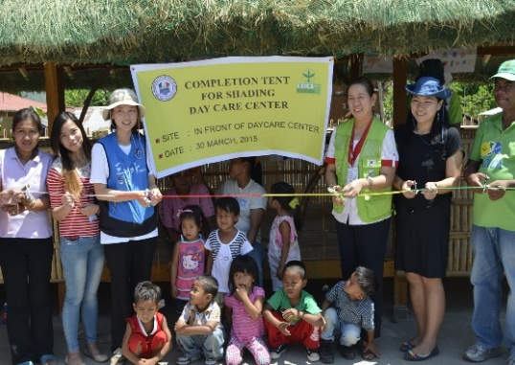
13. Panagkakadua-an Festival | San Felipe, Zambales | 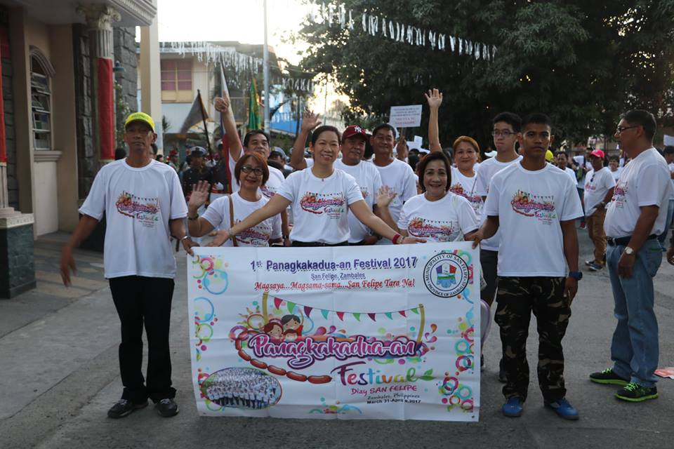  To promote the unique brand of unity, reunions and family bonds of the people, the Panagkakadua-an Festival held a week before the Holy Week every three (3) years, it also serves as a venue to promote products such as the longganisa and the chicharon (bagnet) among others.  From the concerted efforts of the municipal officials and employees, the barangays and every citizen reinforced by the unwavering support of our kababayans abroad and the faith and support of various government agencies to the innate capability of San Felipe and its people, the “PANAGKAKADUA-AN FESTIVAL DIAY SAN FELIPE, ZAMBALES” served as a tourism platform for San Felipe. It also served as a celebration of galore, merry-making, homecomings, street dancing, songs and display of color and artistry as well as a fitting time to relish the leaps and bounds the municipality has taken in the past years that calls for a celebration of our triumphs and successes. | Intangible | Government owned Program | 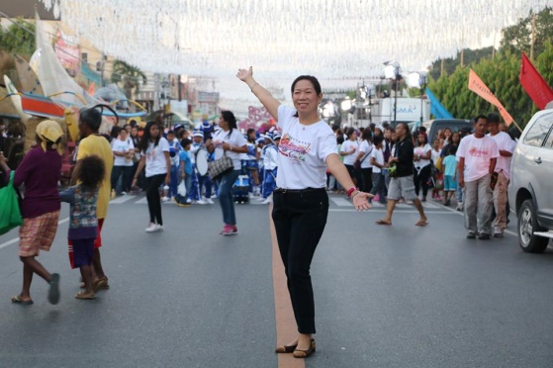
14. Foundation Day of San Felipe | San Felipe, Zambales | In celebration of the foundation day of San Felipe, Zambales in its separation from the Municipality of San Narciso, Zambales, the LGU San Felipe celebrates this every March 1st of each year. | Intangible | Government owned Program | 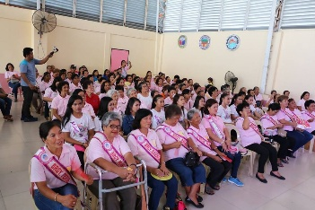  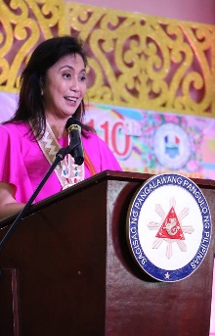
15. San Felipe Community Affair | San Felipe, Zambales | 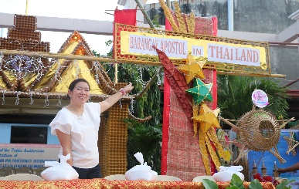  San Felipe Community Affair is an annual affair celebrated during the last month of the year, December and hosted by the LGU-San Felipe. This affair caters folk dance competitions, booth competitions, lantern competitions, acknowledgement of achievers and balikbayans including a conduct of raffle draws as a form of thanksgiving. | Intangible | Government owned Program | 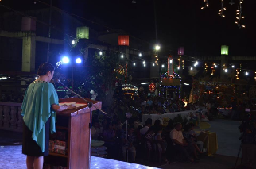  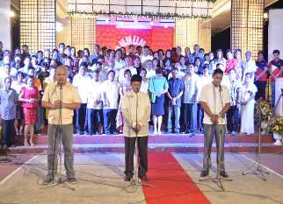
16. San Felipe Grand Family Town Fiesta | San Felipe, Zambales | San Felipe Grand Family Town Fiesta is a 1-week celebration for the town of San Felipe, Zambales celebrated every three (3) years which is all about the PAGKAKAISA (onesness) of the family living within the community and abroad. Just like our own San Felipe product, the LONGGANISA, our community gives a binding characteristic and panagkakadua (unity) to everyone.  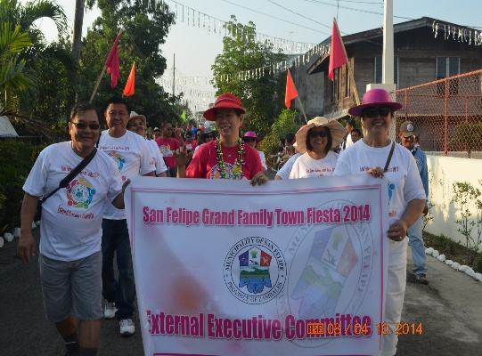  It showcases the quality of every SAN FELIPENEAN, here and abroad, getting involved and giving their share and whole-hearted support, earnestly UNITING and WORKING for the PROGRESS of SAN FELIPE, and with the Blessing of the Divine Providence | Intangible | Government owned Program | 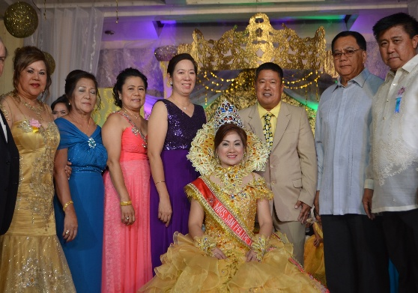
17. Tuklas Talento | San Felipe, Zambales | Tuklas Talento is a variety and talent show of San Felipe, Zambales which caters to the villagers of the town. This variety show inspires individuals to showcase their talents to the community. It is as annual program for the community specially for the youth which usually is conducted within September and October for the Audition and November or December for the Finals. | Intangible | Government owned Program
18. Himig at Indak San Felipe (HI San Felipe) | San Felipe, Zambales | Himig at Indak San Felipe, which is also called as HI San Felipe also serves as a venue to harness talents at the same time promote programs and best practices of the town in songs, dances and music. Its is also a variety and talent show that showcases the talents of San Felipeneans. It is an annual program for the community which usually starts within September and October for the Audition and November or December for the Finals. | Intangible | Government owned Program | 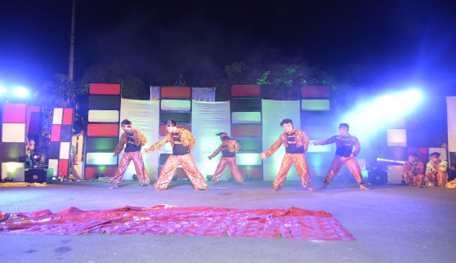  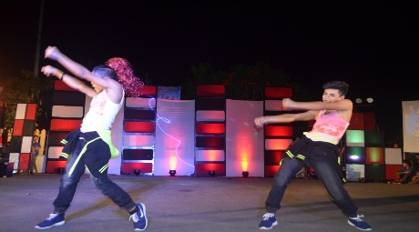
19. Certified Star Factor | San Felipe, Zambales | Certified Star Factor or CSF is also a variety and talent show which showcases the talents of every San Felipeneans in different ways such as singing and dancing. This program was also tapped to promote the Gender and Development Program and other youth oriented programs especially for teenagers to address psycho social issues and health issues such as pregnancy and drugs. This is conducted annually. | Intangible | Government owned Program | 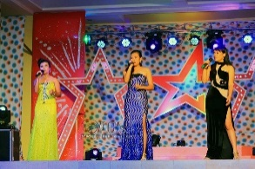
20. Search for the Mutya ng San Felipe | San Felipe, Zambales | Mutya ng San Felipe was first launched on March 1, 2017. This is a beauty, talent and brains pageant for every single lady San Felipeneans aged 15-24 years old. With this pageant, San Felipe products, programs and projects are also showcased. This is a yearly activity celebrated every March of the year usually as part of the celebration of the Foundation Day. | Intangible | Government owned Program | 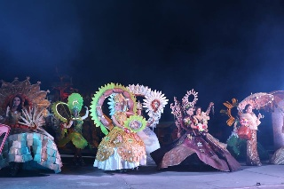  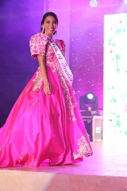
21. Aeta Dances  a. Animal Immitation Dance (sayaw ng mga hayop)  -Sayaw ng mga ibon  -Sayaw ng mga unggoy  -Sayaw ng mga isda  -Sayaw ng paru-paro  b. Courtship Dance (Sayaw ng Panliligaw o Panunuyo)  c. Sayaw ng pagtatanim  d. Dayang-dayang | IP Community of San Felipe Zambales | Aeta Dances are Indigenous People’s culture dances. These dances depict the different ways of living of IP Community. This is also the enactment of how they live and the imitating of the environment around them. These dances also serve as symbolisms of their daily lives. | Intangible | Indigenous People’s Culture | 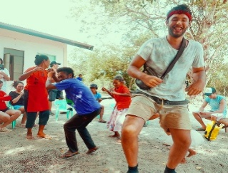  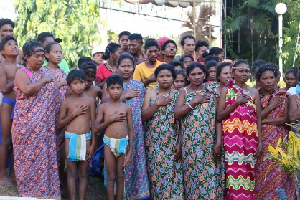  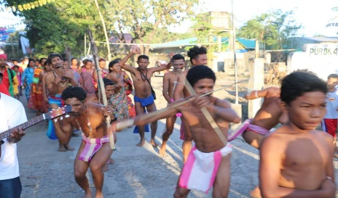
22. IP Ancestral Domain | Sitio Banawen, Brgy. Maloma, San Felipe, Zambales | This is the ancestral domain of the native IP’s of San Felipenean. This is where they occupy the area and lived in the area long time ago. This is their place of living. | Immovable Tangible | Indigenous People’s Cultural Land | 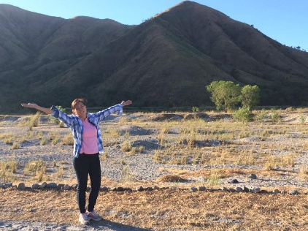
23. Lubong-Nangoloan Waterfalls | Sitio Lubong, Brgy. Feria, San Felipe, Zambales | 3-storey waterfalls which is believed by the locals to depict the legend about the Ilocano Giant named Angalo which left his foot and finger marks in the boulders within the rapids of the waterfalls. | Immovable Tangible | Government Property | 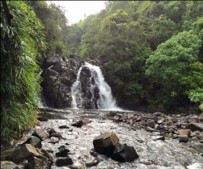  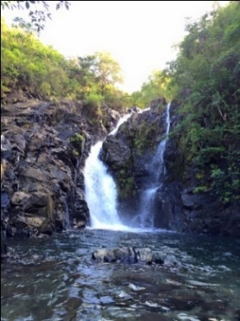
24. Iglesia Filipina Independiente | Barangay Feria, San Felipe, Zambales | The Iglesia Filipina Independiente serves as the evacuation site of some of San Felipeneans during the Mount Pinatubo Eruption.  The Iglesia Filipina Independiente was constructed in the beginning of the twentieth century as part of the broad nationalist struggle against Spanish colonialism and American imperialism. It traces its origin from the struggle of the Filipino clergy against racial discrimination and friar domination within the Roman Church in the 19th century, which, consequently, transformed into a nationalist crusade for the absolute Filipinization of the Church in the twilight years of the 20th century. | Immovable Tangible | Diocese of San Felipe, Zambales | 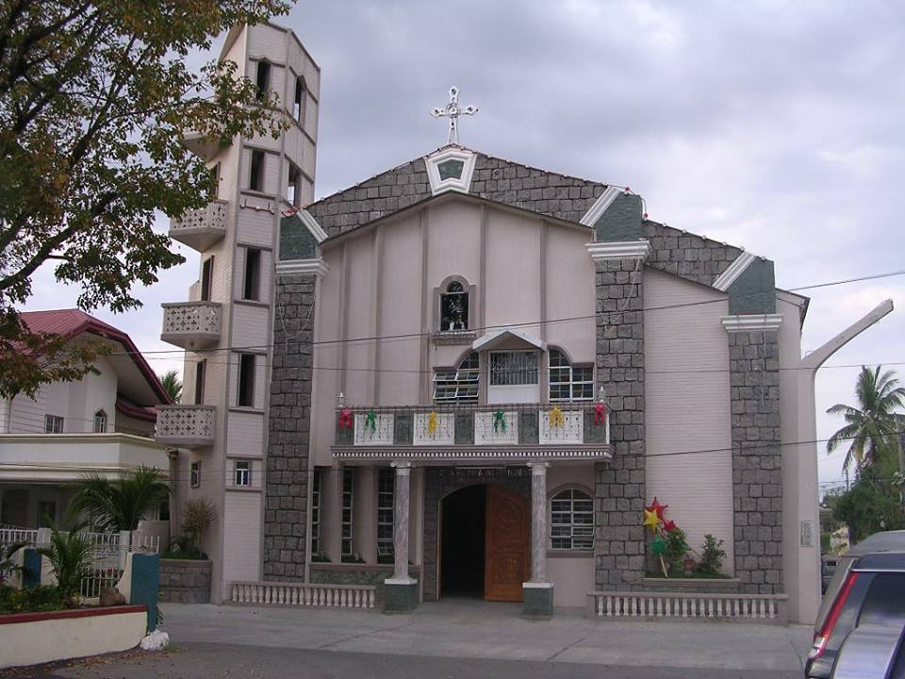

Prepared by: Approved by:

ELSIE C. ALIP ATTY. CAROLYN J. SENADOR-FARIÑAS
Tourism and Investment Promotion Officer Municipal Mayor

